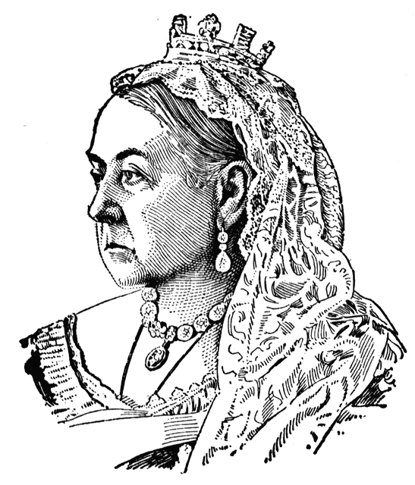
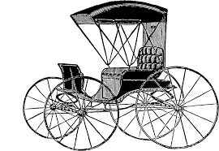
Social Studies 9 Ms. Carey
Chapter 3- Horizons 2nd Edition Textbook
Building a Nation
(1841-1867 in the United Province of Canada)

After the Rebellions of 1837 ended, there was a new rush of immigrants to Upper and Lower Canada. Most were from Britain, and the population of English-speaking people soon outnumbered the French-speaking people. When the colonies of Upper and Lower Canada were joined together after the Lord Durham Report, it became the Province of Canada in 1841. With the union of “The Province of Canada” both English and French were now living in one united area. This led to some tensions and issues for those who were not British. English colonists of all classes still considered themselves to be British (not ‘Canadian’ yet), and they happily followed the views, styles, activities, and prejudices of the Victorians in England. Not all French or other immigrants had the same views and ideas…

- What does Victorian mean? Explain.

- How long was England’s Queen Victoria reign? ___________________
What years? ________________________
- Examine the image on p.84 of your textbook (Figure 3.1) and look at the detail on the expensive building in Toronto that copied London’s “Crystal Palace” building. How would feelings for the mother-country (England), influence those governing the colonies in Canada? Explain and give an example.

- Religion was an important part of life in the Province of Canada in 1841. What was the official religion in the colony? ____________________________________________
- Irish Immigrants were often what religion? _________________________________
- Scottish Immigrants were often what religion? ______________________________
- What year was the first Jewish Synagogue built in Canada? _____________________
- We see that religion was very important in everyone’s daily life in 1841. Give THREE things the Church did for their communities in the Province of Canada.

- Victorian Attitudes & Values (p. 86)
Read the section on Victorian Attitudes & Values on p. 86-87. In a short paragraph (5-7 sentences ), summarize what life was like in the Victorian Era. What did people believe? Value? Find important?

- GET TO THE SOURCE: An Age of Contradiction (p.87)
Read & examine the picture of Queen Victoria at one of her Jubilees. What do you see in this picture? Explain.

- In this picture (p.87), is this picture critical or supportive of Queen Victoria? How might a Victorian person interpret this picture? What about the poor? Explain and give examples.

- A New Age of Science & Medicine in the Victorian Era (p.88)
British North America benefited from the growth of science and technology during the Victorian Era. After 1850, life changed dramatically, particularly in the cities with the Province of Canada. Scientists and inventors made breakthrough after breakthrough.

- When bacteria were studied under the microscopes in the 1870’s, some scientists believed thought that the bacteria were what? ______________________________

- In the mid-1800’s ordinary people could now get vaccinated against what terrible disease? ____________________________

- What were FIVE other diseases at this time that scientists were working on a vaccine or cure for? _______________________________________________________________________

- Since doctors knew almost nothing about hygiene at this time they did not think about doing what when they did surgeries? _______________________________________________________________________

- Sometimes doctors even did what during surgery? ______________________________

- A breakthrough came in 1857. What did French scientist Louis Pasteur theorize and figure out? Explain in a few sentences with specifics.

________________________________________________________________________________________________________________________________________________________________________________________________________________________________________________________________________________________________________________________________________________________________________________________________________________________________________________
- Leisure & Technology (p. 89)
Victorian Canadians liked to be entertained. Name TEN things that they did for entertainment:

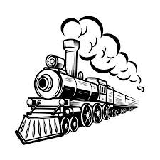
- Changing Technology: (p.90)
What was one of the most important new technologies of the Victorian Age and WHY?

- Canada’s first railway was called what? And where did it go?

Victorian Media: The Newspaper (p.91)
- What was Canada’s first newspaper called and when did it start?

- Why was the newspaper so important in Victorian Canada? How did it attract readers? Explain and give at least two examples.

- DO YOU think there are still Victorian values & beliefs evident in Canada today? Explain with examples.

