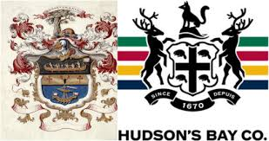
Social Studies 9 Ms. Carey
Confederation: What about the West?
Impact of the Fur Trade (HBC vs. NWC)
Name:
Date:
Block:
After Confederation was achieved, there were still some major issues across the new ‘Canada’ and the colonies that had not yet joined. The land in the West (or the Northwest) consisted of Manitoba, Saskatchewan, Alberta, and BC) and the Fur Trade was the big economic industry in these regions. Trade opened up contact between Indigenous and Europeans and caused exploration of the vast region. Two companies, the Hudson’s Bay Company (HBC) and the North West Company (NWC) – and not Kayne West’s kid FYI…, were the two major players in the Fur Trade that helped shaped the development of the West.
Please read p.124-134 and answer the following questions:
- Examine the differences between the Hudson’s Bay Company and the North West Company. Use the T-Chart below to compare and contrast the two companies.

- After completing the T-Chart, which Fur Trading company (HBC or NWC) do you think was the better organization/company and why? Give reasons for your answer.

- Examine the map on p.128 of your textbook (Figure 4-3). Identify which company had more trading posts and routes in the year 1820.

- Read p. 130-132. Explain in your OWN words the impact the Fur Trade on the Indigenous peoples in the North West.

- Read p.134-135. Why were the traditional roles of Indigenous (First Nation) women so important to the fur trade? Explain and give at least THREE reasons.

- Who were the METIS? Explain.

