Social Studies 9 Ms. Carey
Chapter 5: The Triumph of Steam
The Industrial Revolution…

This Chapter will examine the following topics:
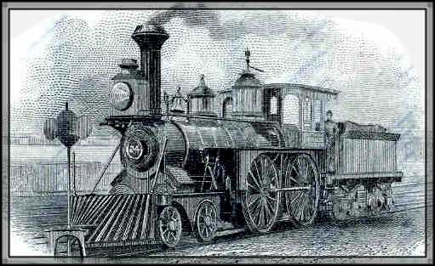
- The Agricultural Revolution (p.130)
- The Economic Revolution (p.134)
- Transportation (Trains) (p.141)
- The Factory Age “The Young & the Rightless” (p.143)
- Factory Life
- Child Labour (then and now)
- Factory Acts & Reforms

Introduction:
Not all Revolutions are violent… Some revolutions happen as a result of new inventions and new ways of doing things. After 1700, the ways of growing food, and manufacturing and transporting goods changed completely in Great Britain. This change was great enough to be labelled a ‘revolution’- The Industrial Revolution.

The technologies of the Industrial Revolution transformed the old, traditional ways of farming. New towns and cities filled with people seeking employment in factories where new products were being made quickly and cheaply. Great Britain’s economy grew enormously and many people became very wealthy. However… the majority of people who worked in the factories endured long, hard hours of work in unsafe conditions for very little pay. Cities became even more dirty, crowded, and disease ridden. Even small children had to work in dangerous, unsafe, and cruel conditions.

The history of the Industrial Revolution is also the history of working peoples’ struggles to enjoy some of the benefits of the new technologies themselves. They were fighting for rights in the workplace, fair wages, and an opportunity to make enough money to purchase the goods or products they were making in the factories. This economy soon became global with the expansion of trade overseas to the new colonies. This also changed how humans interacted with nature and the environment. With the burning of coal in the factories to creating pollution, global warming, and the depletion of the ozone layer, the Industrial Revolution forever changed our world…
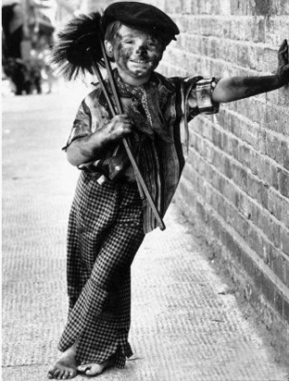
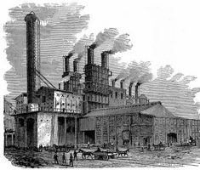

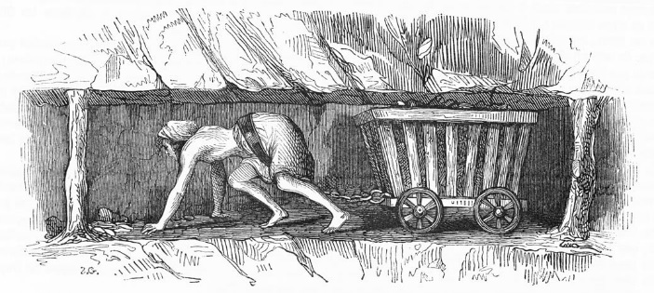

So Why did this start in Britain? (p.129)
Please read pages 129-130 and in the box below write a brief summary explaining why the Industrial Revolution started in Britain.

