Socials Studies 9 Ms. Carey Aftermath of the 1837 Rebellions in Upper & Lower Canada
LORD DURHAMS’S REPORT

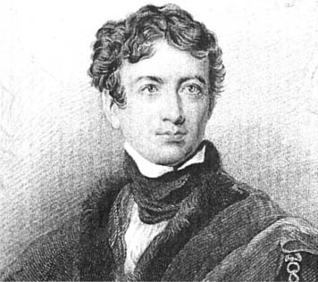
Name: __________________________ Date: ________________________ Block: __________
The Rebellion in Lower Canada ended French-Canadian hopes for justice and democracy under the British Empire. The ACT OF UNION which followed in 1840, joined the colony with English-speaking Upper Canada. Radical ideas were purged, and English became the language of government. While union may have resulted in a larger, stronger colony headed in the direction of a more responsible government, it also brought a sense of loss to many of the residents of Lower Canada. Feelings of loss and betrayal meant that political strife in the Canadas was not at and end… (p.78-80)

- Who was Lord Durham and how did he make his fortune?

- When Durham arrived in 1838, who did English and French Canada view him?

- Without the Councils and Assembly, Durham was known as what? ______________________

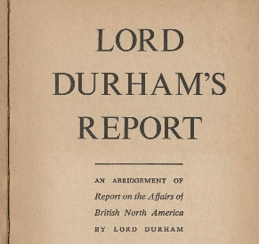
- What is the Durham Report? What did Lord Durham suggest to England as his recommendation?

- Do you think his recommendations were the right thing to do? Yes or No? Explain.

- What did Lord Durham conclude was the ‘real problem’ that he didn’t mention in his report?
- Durham had correctly reasoned what? That… __________________________________________________________________________________________________________________________________________________________________________________________________________________________________________.

- Durham proposed changes to the structure of what? Explain and identify the consequences of this change based on the existing structure in both Upper and Lower Canada.

- Explain what the ACT OF UNION was and what did it do? Explain.

- Examine p.80 “Get to the Source: Lord Sydenham Proclaims Act of Union”. Would anything in his speech make you doubt his words? Explain.

- Explain why Lord Durham’s words on p.78 would have been difficult for French Canadians to see Durham in a positive light.

- Explain why you think Indigenous peoples tended to avoid involvement with the Rebellions of 1837.
