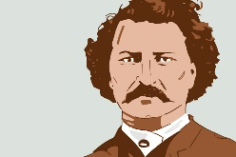
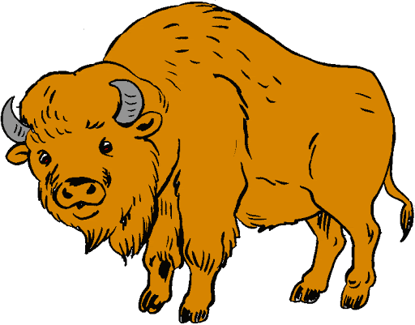
Social Studies 9 Ms. Carey
The Metis & Red River Valley Assignment
The Northwest from 1800-1860
Name: ________________________
Date: _________________________
Block: ________________________
Please read pages 138-145 of your textbook (Horizons 2nd Edition) to answer the following questions.
- Why did fur traders begin marrying the daughters of local First Nation families and why was this practice encouraged? Explain.

- How did the NWC and HBC feel about these marriages? Explain how each company felt.

- A growing number of people in the Northwest became children of European fur traders and First Nation Indigenous women. These children were something entirely unique to Canada. Explain how this would be unique and where did the term ‘Metis’ come from?

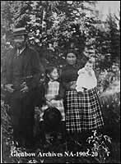
- Look at Figure 4-11 on p.139 of a Metis family in Alberta in 1890. What evidence does this photo provide about the merging of the European and Indigenous cultures?
Give at least THREE examples.

- What are BISON and why was the Bison Hunt so important for the entire community? Explain.

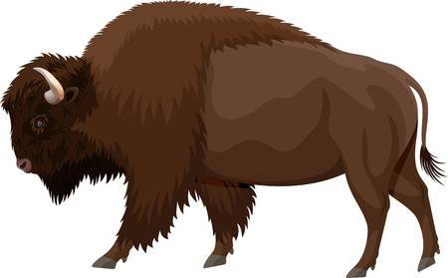

- Examine Figure 4-14 on page 141 “Zoom In: The Red River Cart” of the photo of Main Street in Winnipeg in 1879. Why would such a wide street be unusual in a town or city and why was it like this in Winnipeg?
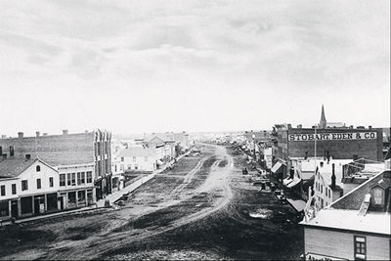

- Examine the “Laws of the Bison Hunt” on p.142. What do these rules tell us about the bison hunt? What do they show us about the Metis people? Explain.

- Who was the Earl of Selkirk and why has he been called an “unrealistic idealist”? Find evidence to either support this or deny this claim and explain why you picked your evidence.
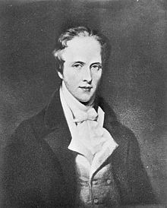

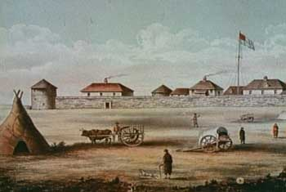
- What was the Selkirk Settlement also known as?

- What was the Pemmican Proclamation? Explain.

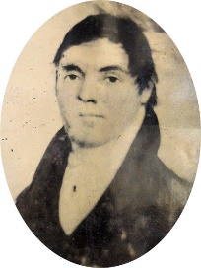
- Read p.145 AND p147. Who was Cuthbert Grant and why did the North West Company turn to him for help in the Red River Valley? Explain.

- Why was the Battle of Seven Oaks fought? Explain why it happened in your own words.

- How could the Battle of Seven Oaks be seen as a turning point in Metis history?

