AP Psychology 12 Unit 14 Ms. Carey
Module 77- Prejudice & Discrimination
Name: _________________________________ Date: _____________________ Block: _____________
As we move into the “Social Relations” part of Unit 14, we begin with prejudice and discrimination. Please read along the module and answer the following as you go:
- Define Prejudice

- Define Stereotypes

- Define Discrimination

- Explicit vs. Implicit Prejudice
Again and again, we have seen that our brain processes thoughts, memories, and attitudes on two different tracks.

Explain Explicit processing:
Explain Implicit processing:

- Targets of Prejudice (p.793)
What groups are frequent targets of prejudice? In your OPINION, why do you think the following groups are targets of prejudice based on social thinking so far?

  - Racial & Ethnic Prejudice
  - Gender Prejudice
  - LGBTQ Prejudice
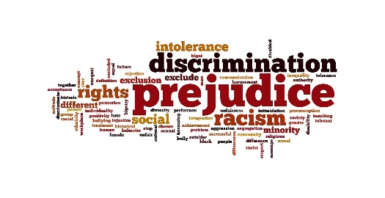
- Roots of Prejudice (p.796)
What are some social, emotional, and cognitive roots of prejudice and what are some ways to eliminate it? Define the following:
    - Just-World Phenomenon
    - Ingroup
    - Outgroup
    - Ingroup Bias

    - Scapegoat Theory
    - Other-Race Effect

Part D: Review
Please answer the following questions:
- How do explicit and implicit prejudice differ? Explain.

- What are some examples of ingroup bias in your community?

- What is the difference between prejudice and discrimination? Explain.
**when done, complete the 5 MC Questions on page 800 as well

