Socials 9 Ms. Carey
Napoleon Quote Activity
Name:_________________________
Date:__________________________
Block:_________________________
Using the following Napoleon Quotes, explain what Napoleon may have meant. Use Examples to support your ideas.
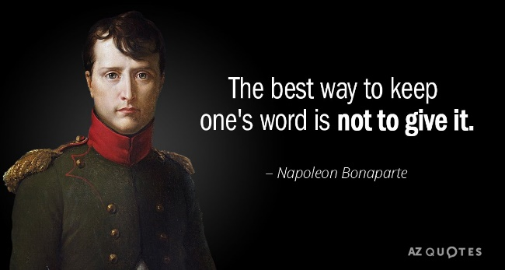
1)

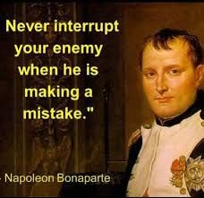
2)

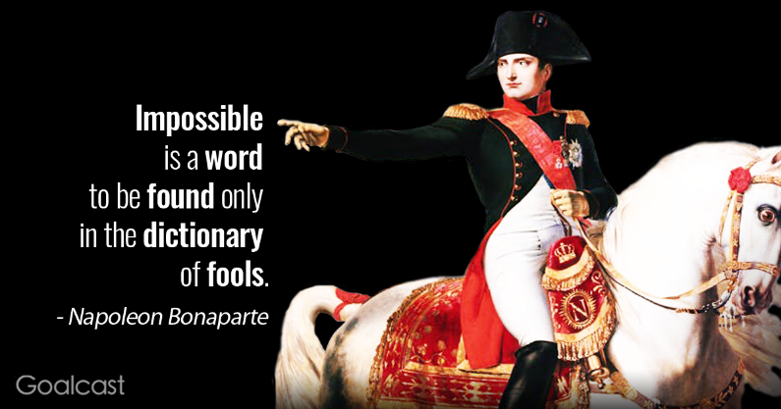
3)

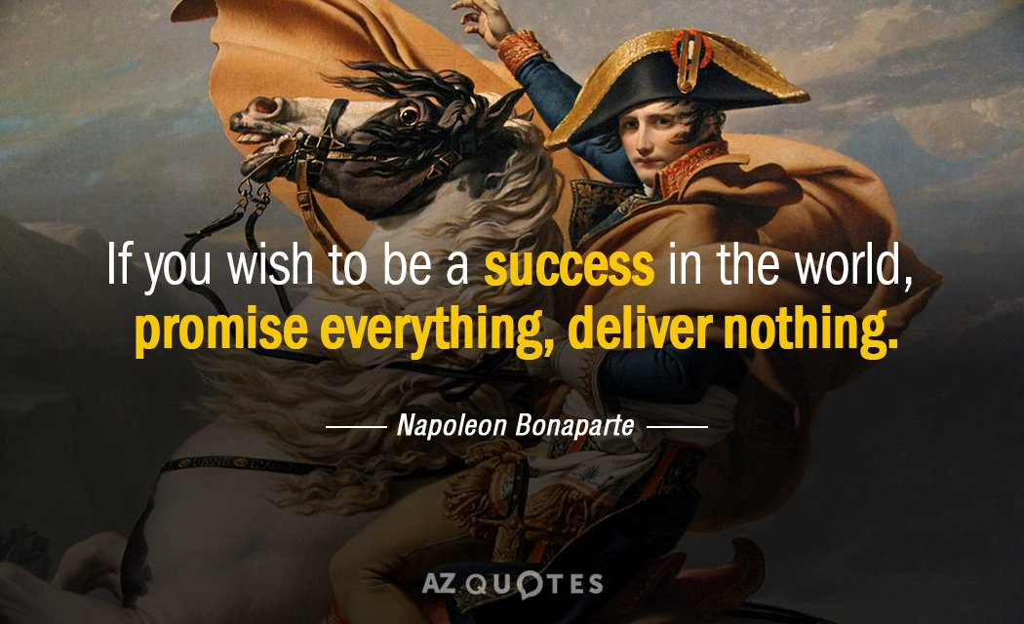
4)

