Social Studies 9 Ms. Carey
The Start of the American Revolution
“Troublesome Colonists or Poor British Government Decisions?”

Name: ___________________________ Date: _________________________ Block: ___________

The British thought that the American Colonists were troublesome and argumentative. They had stirred up trouble with both the French in Quebec and with the Indigenous peoples, and usually lost the fights in which they became involved in. Time and again, British troops and ships had brought victory, but military actions cost money. These victories were being paid for by British taxpayers. It seemed only right that Americans should pay part of the bill for these military campaigns as well. When the British Government tried to tax Americans- without their agreement- they resisted. Let’s look at this issue from BOTH perspectives:
Part A: Perspective Activity (p.302-303 of your textbook)
Explain how both the American Colonists and the British Government felt about the increased taxes to pay for the military campaigns.
American Colonists British Government (King George III)

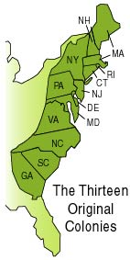
In your opinion, who was more justified? The American Colonists or the British Government? Explain your answer.

Part B: Events leading to Revolution
The American Colonists were not happy with two laws the British Government had passed (The Royal Proclamation and The Quebec Act) and felt like they were cut off, isolated, and now having to pay taxes. The American Colonists knew that it was difficult to oppose the British and that people had many close links with Britain (raw materials, trade, products, supplies) and that a potential loss of this close relationship with Britain could be a problem. However, the Colonists knew that if they were to have any hope in pushing their issues and concerns, they had to unite with the other Colonists to present a united front to Britain. They decided at the Continental Congress of 1774 to work together in spite of what the British King George III wanted. This was the first step taken towards creating a new nation…

- The Stamp Act of 1765
The British Government passed the Stamp Act that made Americans pay a small tax similar to our GST tax today in Canada. This Act placed taxes on many goods and services. This tax was in the form of a stamp that people had to buy and stick on everything, even a deck of cards. The money generated from this Stamp Act was supposed to pay for the costs of defending the American Colonies.
Reading page 303 of your textbook, how did the American Colonists respond to this Stamp Act?

American Response to Stamp Act:

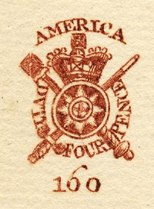
Was the Stamp Act a success or a failure? Explain.

What did the Colonists own words “taxation without representation” mean? Explain.
Part C: Tensions Rising…
After the failure and repeal of the Stamp Act in 1766, the British Government still wanted to raise money to pay for the Colonies and their costs. While the British Government saw itself as reasonable, the Americans were unsettled. A list of things happened that caused more tensions:
- British Troops were everywhere in the colonies now and Americans were asked to let soldiers stay in their home or pay for the soldier’s lodgings (hotels)
- In 1770 nervous British soldiers misunderstood an order and accidently fired their muskets into a mob (group) of people in Boston who were protesting and killed several people. This so-called “Boston Massacre” hurt the British reputation and American Colonists were not happy.
- Over the next few years, violent incidents occurred between the British soldiers and the Colonists.
- Colonial Leaders who now called themselves “SONS OF LIBERTY” were ready to fight the British…

THE BOSTON TEA PARTY- 1773
In most American ports, the resistance group known as The Sons of Liberty (also known as PATRIOTS) scared off British tea-carrying ships by threatening their captains with tarring, feathering or worse. However, when three tea ships, the Dartmouth, the Eleanor & the Beaver, arrived in Boston Harbor in 1773, the colonists demanded that the tea be returned to England in protest of the Tea Act. Thomas Hutchinson, the British-appointed governor of Massachusetts, refused to permit the ships to leave.

Patriot leader Samuel Adams of the Sons of Liberty group began organizing the now-famous “tea party” with about 60 other members of the Sons of Liberty. On December 16th 1773, the Sons of Liberty disguised themselves as Mohawk First Nations and boarded the three British tea ships docked in Boston Harbour. They then dumped 342 chests of tea into the water. Now known as the “Boston Tea Party,” the midnight raid was a protest of the Tea Act of 1773, a bill enacted by the British parliament to save the faltering British East India Company by greatly lowering its tea tax and granting it a virtual monopoly on the American tea trade. The low tax allowed the company to sell its tea even more cheaply. Many colonists viewed the act as yet another example of Britain’s taxation tyranny.
The British tea dumped into Boston Harbor on the night of December 16 was worth more than $700,000 in today’s currency.
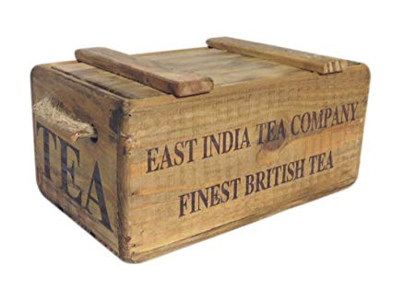
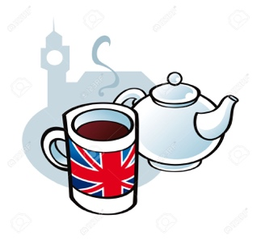
Parliament, outraged by the blatant destruction of British property, enacted the Coercive Acts, also called the “Intolerable Acts” by the colonists, in 1774. The Coercive Acts closed Boston to merchant shipping, established formal British military rule in Massachusetts, made British officials immune to criminal prosecution in America, and required colonists to quarter/house British troops. The colonists subsequently called the first Continental Congress to consider a united American resistance to the British… here comes the Revolution….

THE BOSTON TEA PARTY:
What happened on both sides of the issue? What caused this and who did what?
American Colonists British Government (King George III)

Do you feel that Samuel Adams and the Sons of Liberty had the right to destroy the tea (property of the British and Tea Company?) Explain your answer.

What additional problems or issues could have happened from the Sons of Liberty disguising themselves as Indigenous Mohawk Peoples when they raided the British ships and dumped the tea? Give at least TWO issues or problems that could have occurred because of this…

