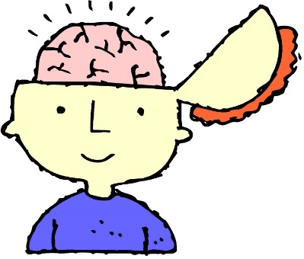
AP Psychology 12 Ms. Carey
Unit 11- Intelligence
(Modules 60-64)
Name: ___________________________
Date: ____________________________
Block: ___________________________

Module 60- Introduction to Intelligence
- Define Intelligence:

- Who is Charles Spearman and what did he believe we had? Explain.

- The idea of a general mental capacity expressed by a single intelligence score was controversial in Spearman’s time, and it remains so today. What did Spearman’s opponent L.L. Thurstone (1887-1955) do that did not rank people on a since scale of general aptitude? Explain.

Theories of Multiple Intelligences:
Explain each of the following theorists and summarize their theories:
- Howard Gardner-

- Robert Sternberg-

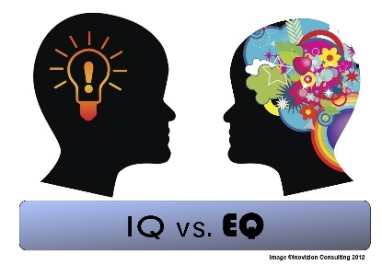
Define Emotional Intelligence:

Hint Hint… know Table 60.1 on page 630 of your textbook.

Module 61- Assessing Intelligence (p.632)
- What is an intelligence test?

- What is an Achievement Test and give an example?

- What is an Aptitude Test and give an example?

Who was Francis Galton & what did he believe? Explain.

Who was Alfred Binet and what was he tasked to do? Explain.

- What is Mental Age?

Who was Lewis Terman and what did he try to measure? Explain.

What did William Stern create in German? Explain.
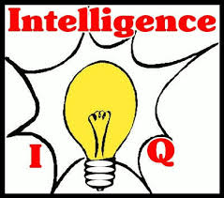

What is the formula Stern used to calculate this? Write it out… (p.634)

Who was David Weschler and what two tests did he create? Explain.

PRINCIPLES OF TEST CONSTRUCTION:
To be widely accepted, a psychological test must meet three criteria. What are the three criteria?
- ____________________________________________
- ____________________________________________
- ____________________________________________

- Define Standardization. What would make a test STANDARDIZED? Explain.

    - What is the Flynn Effect?

- Define Reliability. What would make a test RELIABLE? Explain.

- Define Validity. What would make a test VALID? Explain.

    - Define Content Validity:
    - Define Predictive Validity:

Module 62 (p.640)
Define CRYSTALLIZED INTELLIGENCE and give an example.
Define FLUID INTELLIGENCE and give an example.

