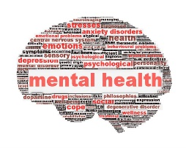
AP Psychology 12 Ms. Carey
Unit 12: Intro to Psychological Disorders Assignment
(Module 65)
Name: ________________________
Date: _________________________
Block: ________________________
For this assignment you need to read Module 65 (p.666- 676) to answer the following questions.

- What is a psychological disorder? Define.

- There are TWO different models or approaches that influence our understanding of psychological disorders. Define each of them and their approach:
  - The Medical Model-

  - The BioPsychoSocial Model -
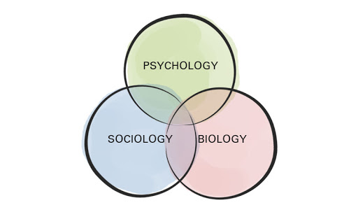

- Define epigenetics:

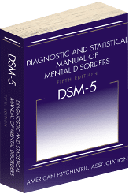
- What is the DSM-5 and what is its purpose? What does it NOT do?

- Examine the Thinking Critically About ADHD on p.671. Why is there controversy over attention-deficit/hyperactivity disorder?

- How do we draw the line between normality (really what is ‘normal’??) and disordered behaviour?

- Why do some psychologists criticize the use of diagnostic labels? Why do we need to be very cautious when using labels? Explain.

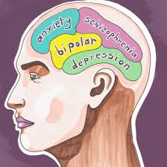
- Try the 4 Multiple Choice questions on p.676. The answers are:

1) c
2) a
3) a
4) d

