AP Psychology 12 Ms. Carey
Unit 7- COGNITION
Memory
Modules 31-33
Name: _________________________
Date: __________________________
Block: __________________________
Module 31- Studying and Encoding Memories (p.326)
- Define Memory-

- To a psychologist, evidence that learning persists includes these three retention measures:
1) Recall –

2) Recognition-

3) Relearning –
A famous pioneering memory researcher was named Hermann __________________________________.
Memory Models: How do psychologists describe the human memory system?
- ENCODING -

- STORAGE -

- RETRIEVAL -

Define Parallel Processing-

To explain our memory-forming process Richard Atkinson and Richard Shiffrin (1968 & 2016) proposed a three stage model… Explain/Define each of these stages:
1) SENSORY MEMORY
2) SHORT TERM MEMORY
3) LONG TERM MEMORY
This model has since been updated by Alan Baddeley & others with the following editions.
Please define them.
Working Memory

Automatic Processing

Dual Track Memory: (p.330)
Effortful Versus Automatic Processing
- Define EXPLICIT MEMORY

- Define EFFORTFUL PROCESSING

- Define AUTOMATIC PROCESSING

- Define IMPLICIT MEMORIES

SENSORY MEMORY (p.331-332)
Define ICONIC MEMORY -

Define ECHOIC MEMORY –

EFFORTFUL PROCESSING STRATEGIES (p.333-334)
What are some effortful processing strategies that can help us remember new information?
- Define Chunking AND give an example-

- Define Mnemonics AND give an example –

- Define Hierarchies AND give an example-

What is SPACING EFFECT?

What is TESTING EFFECT?

What is SHALLOW PROCESSING?

What is DEEP PROCESSING?

Module 32- Storing & Retrieving Memories (p.339)
Memory Storage- Retaining information in the Brain:
EXPLICIT MEMORIES
- What roles do the frontal lobes and hippocampus play in memory processing? Explain.

- Define Semantic Memory and Episodic Memory

- What is the hippocampus and what is it responsible for?

- Explain Memory Consolidation:

IMPLICIT MEMORIES:
What roles do the cerebellum and basal ganglia play in memory processing?
A) The Cerebellum:

B) Basal Ganglia:

How do emotions affect our memories?
A) Amygdala:

B) Flashbulb Memories:

Synaptic Changes:
- Define Long Term Potential (p.342)

OUR TWO MEMORY SYSTEMS:
Please complete the following diagram using Figure 32.4 on p.344
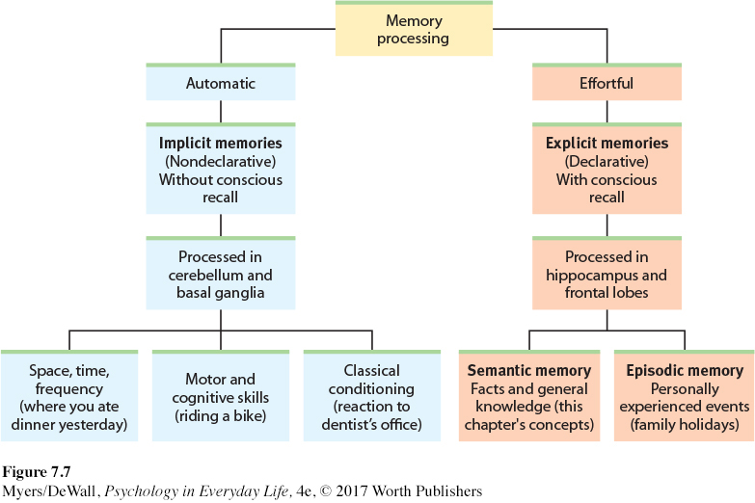
MEMORY RETRIEVAL (p.344)
- Define Retrieval Cues:

- Explain Priming:

- Explain Encoding Specificity Principle:

- Explain Context-Dependent:

- Explain State-Dependent:

- Explain Mood Congruent Memory:

- Define the Serial Position Effect:

MODULE 33: Forgetting, Memory Construction, and Improving Memory (p.350)
- Define Anterograde Amnesia:
- Define Retrograde Amnesia:
- Explain Encoding Failure:

- Explain Storage Decay:

- Define and give an example of PROACTIVE INTERFERENCE:

- Define and give an example of RETROACTIVE INTERFERENCE:

- Define Regression:

- Define Reconsolidation:

- Define the Misinformation Effect:

- Explain what source amnesia is:

- Define déjà vu:

IMPROVING MEMORY: (p.362)
What are the SEVEN ways they propose improve memory? List them below:

*** Who is HERMAN EBBINGHAUS and what does his forgetting curve show us about the nature of storage decay??

