Social Studies 9 Ms. Carey
Upper & Lower Canada: Life after the War of 1812
UPPER CANADA Worksheet
(p.49-56)

Name: _______________________ Date: ________________________ Block: ___________

- Who were the loyalists and why did the move to Upper Canada? Explain.

- In 2-4 sentences, explain what daily life was like in Upper Canada.

- Why did people not light their homes after it got dark? Explain.

- What is a barter-economy? Explain and give an example from Upper Canada.

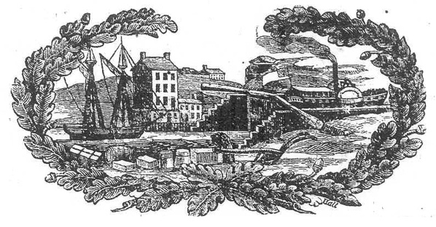

- Why did life in the colonies (Upper Canada) have a way of removing some of the barriers between social classes? (p.52) Explain.

- What was a tenant farmer? Explain.

- What was ‘an estate’? Explain.

- Who were the Family Compact in Upper Canada?

- Who were the Chateau Clique in Lower Canada?

- Examine the quote on p. 53 in the “Get to the Source” written by Susanna Moodie, colonist and author. What does this tell us about how the upper class was seen in Upper Canada at the time? Explain.

- Who were absentee landlords and why were they a problem? Explain.

- Who owned the best land in Upper Canada?

- Many colonists had no option but to do what when it came to purchase land in Upper Canada? Explain.

- Read the quote from one upper-class British colonist on page 55. What is this quote referencing? Explain what you think he is talking about.

- Colonists hoped to find land in Upper Canada. Identify three barriers they faced ranking them in importance:

- Identify TWO early signs of conflict in Upper Canada from your reading.

