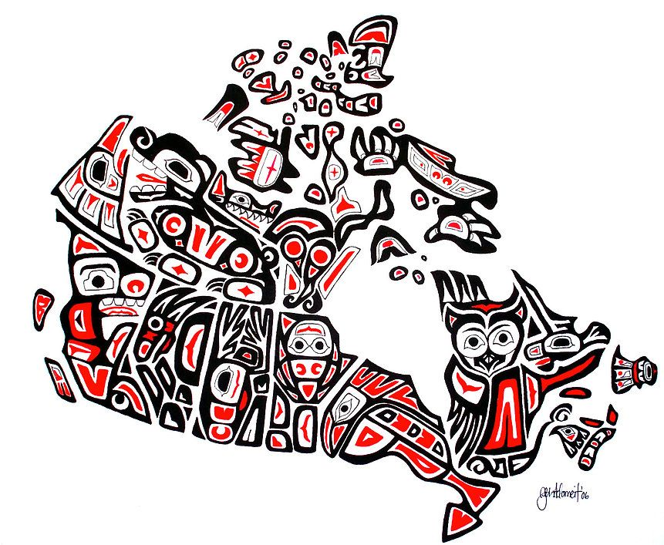
Social Studies 9 Ms. Carey
Victorian Times & Aboriginal Peoples
(p.93-97 Horizons 2nd Ed. Textbook)

Name: ____________________________
Date: _____________________________
Block: ____________________________
Please read pages 93-97 and answer the following questions.
- What is a reserve? Define.

- Read the excerpt on p.93 from Little Pine, 1849. Summarize in your own words what he is saying.

- Look at Figure 3-15 on p.94 (the Maps). What conclusions can you draw by comparting the two maps? Tell me about what you see and suspect.

- Define the following terms:
  - Band-
  - Assimilate-
  - Enfranchisement-
  - Elders-

- Give THREE examples of assimilation in Canadian History.

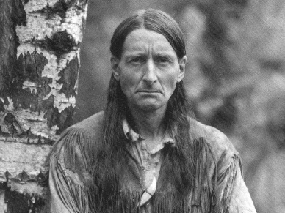
- Read the Cross Currents Case Study on p.96 focusing on GREY OWL: Champion or Fraud? After you read it, answer the following:
“Does Grey Owl’s positive image regarding his support for conservation excuse him, even though he committed a huge hoax? Give your opinion with supporting detail from the reading.”

- Many people believe that the act of settling First Nations on reserves and forcing them to adopt European ways was cultural genocide. What does this mean? Explain.

- What is a residential school? Define and explain.
(you may need to do some research to fully answer this question)

- On p.97 there is a photo (Figure 3-18).
What does the photo tell us about the residential school? Explain.

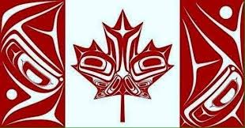
ONLINE RESEARCH QUESTION:
Now that you have read about how the Victorian Era Europeans in early Canada treated
the Indigenous peoples, what is being done in Canada today to try and help resolve some
of the matters? Do some research online and list at least TWO things being done today to
try and resolve past mistakes.

