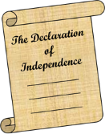
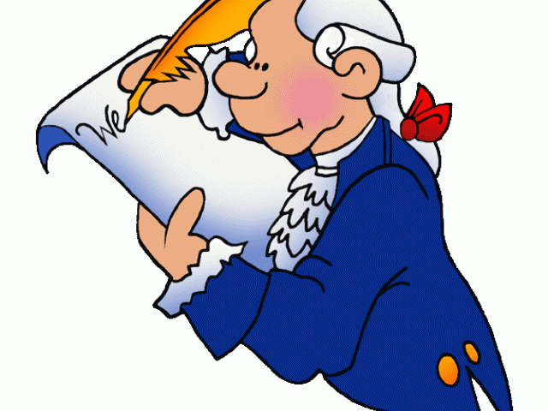
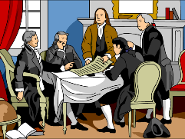
Social Studies 9 Ms. Carey
The American Revolutionary War & The Declaration of Independence
Name: ______________________ Date: _____________________ Block: ____________
The opening shots of the American Revolution were fired on Lexington Green, in Massachusetts. As British and American soldiers faced each other, the situation was tense. A shot was fired -probably by an American according to accounts. The ‘shot heard around the world’ caused the British to fire on the Americans and the war had started. The Americans knew they needed an army on the battlefield to fight the British. With the help of colonial leaders such as GEORGE WASHINGTON, the revolutionaries were able to putt together a sizable force.
While fighting continued the battlefield, the colonial government officials met at the Continental Congress and it seemed obvious to all that independence from Britain was the only option. Some other important people such as BENJAMIN FRANKLIN, THOMAS JEFFERSON, and JOHN ADAMS agreed. Together they decided to draft a statement that would declare their independence from Britain. This document, mostly written by Thomas Jefferson, in 1776, is the American Declaration of Independence. This declaration did not end the war. In fact, it caused King George III in Britain to enlarge the army and navy and the war lasted another SEVEN YEARS!! It was a great hardship on both sides. France even joined the Americans in the war against the British! By 1783 the British knew they were in trouble and the war had ended.
The colonists, who had begun by protesting taxes on tea, sugar, and stamps, had won a revolution, and created the UNITED STATES OF AMERICA.
Thomas Jefferson was asked to write one of America’s most important documents. It was a statement of human rights, a list of complaints against the British,, and a formal announcement of Independence. On July 4th 1776 the Continental Congress signed it. The opening of it says:

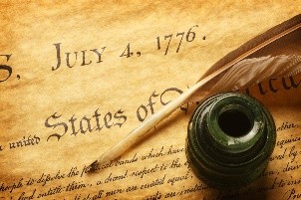
In a well-written paragraph (opening and closing sentences, 5-9 sentences,
proper grammar, capitalization, etc), answer the following:
“Imagine you are King George III of England. You have invested a LOT of money, resources, and men into the American Colonies over the years. You have been given an ‘advance copy’ of this Declaration of Independence. What is your (King George’s) reaction to this document.”

